SIMATS ENGINEERING
ASSESSMENT TOOL 2

COURSE NAME: Database Management Systems
COURSE CODE: CSA0509

COURSE OUTCOME COVERED

CO4: Design database solutions incorporating file organization, indexing, and hashing techniques to optimize data storage and retrieval efficiency. (BL3, BL4)

Activity Tool : Industry Problem Solving Task (Medium)
Assessment Tool Weightage: 35%

Dr

QUESTIONS Total Marks: 50
Q.No | Question | Bloom's Level | Marks
1 | An e-commerce company needs to store 10 million product records. Recommend a file organization strategy and justify your choice with cost analysis. | BL4 – Analyze | 5
2 | A banking system requires fast retrieval of transactions by account number and date range. Design an indexing strategy with appropriate index types. | BL4 – Analyze | 5
3 | A healthcare system stores patient records accessed both by PatientID and by doctor name. Design a multi-level indexing solution. | BL4 – Analyze | 5
4 | A logistics company needs to efficiently handle dynamic insertions and deletions of shipment records. Analyze whether B-Tree or B+ Tree is more suitable. | BL4 – Analyze | 5
5 | Design a hashing scheme for an HR system with 5000 employees. Evaluate static hashing vs. extendible hashing for your scenario. | BL3 – Apply | 5
6 | An airline reservation system must support point queries by flight number and range queries by date. Propose a combined index structure. | BL4 – Analyze | 5
7 | For a university student database, design the file organization and secondary indexing to support fast queries by department and CGPA range. | BL4 – Analyze | 5
8 | Analyze the disk block utilization for Heap, Sorted, and Hashed file organizations given 100,000 records with 50 bytes each and 4KB blocks. | BL4 – Analyze | 5
9 | A social media platform needs to index 500 million posts by user_id, timestamp, and hashtag. Design a composite indexing strategy. | BL4 – Analyze | 5
10 | Compare the performance (insert, delete, search time) of Heap File, Sorted File, and Hashed File for a supermarket billing system with 1 million daily transactions. | BL4 – Analyze | 5

Code of Conduct:

I Lokesh S (192511037) (Name / Reg No) certify that this submission is my original work and that I have adhered to the guidelines specified for this assessment.
I understand that any violation of academic integrity rules will result in disciplinary action.

Signature of the student: Lokesh S

RUBRICS FOR CALCULATION:

Criteria | Weightage | Level 4 – Exemplary | Level 3 – Proficient | Level 2 – Developing | Level 1 – Beginning
Criteria | Weightage | Level 4 – Exemplary | Level 3 – Proficient | Level 2 – Developing | Level 1 – Beginning
Understanding of Industry Problem | 20% | Comprehensive understanding of real-world problem and constraints | Good understanding with minor gaps in requirements | Basic understanding; some requirements unclear | Poor understanding; misinterprets problem context
Application of Engineering Concepts | 25% | Applies advanced and relevant concepts effectively to solve the problem | Applies appropriate concepts with minor errors | Limited application of concepts | Incorrect or no application of concepts
Solution Design | 25% | Innovative, practical, and feasible solution aligned with industry standards | Logical and feasible solution with minor gaps | Basic solution with limited feasibility | Unclear or impractical solution
Use of Tools | 15% | Effective use of modern tools, technologies, and real data | Appropriate use of tools with correct implementation | Limited or inconsistent use of tools | Minimal or incorrect use of tools
Analysis | 10% | Thorough analysis with validated results and performance evaluation | Good analysis with reasonable validation | Basic analysis with limited validation | Poor or no analysis
Professionalism | 5% | Highly professional, well-documented, and clearly presented work | Good documentation and presentation | Basic documentation with some gaps | Poor documentation and presentation

1. Question
For an e-commerce company storing 10 million product records, recommend a suitable file organization technique. Justify your choice based on search, insertion, deletion, and range-query performance.

Answer
A B+ Tree-based indexed file organization is recommended. Product records are frequently searched using fields such as ProductID, category, and product name. B+ Tree indexing provides efficient searching with approximately O(log n) access time and reduces disk I/O. It also supports efficient insertion, deletion, and range queries.
Assuming each record occupies 200 bytes:
$$10,000,000×200=2,000,000,000 bytes$$
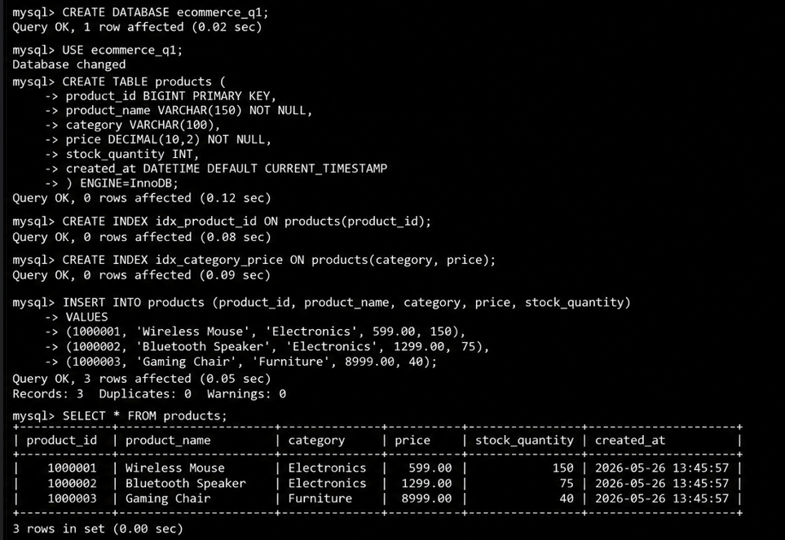
Therefore, approximately 2 GB of storage is required, excluding indexes and metadata.
A heap file provides fast insertion but slower searching, while a sorted file provides fast searching but expensive insertion. Therefore, B+ Tree indexed organization provides a good balance between search, insertion, deletion, and range-query performance.

2. Question
A banking system needs fast retrieval of transactions based on Account Number and Date Range. Design a suitable indexing strategy.

Answer
A composite B+ Tree index on Account_Number and Transaction_Date is suitable.
CREATE INDEX idx_account_date
ON Transactions(Account_Number, Transaction_Date);
This allows fast retrieval of transactions for a particular account and efficient searching within a date range.
SELECT *
FROM Transactions
WHERE Account_Number = 10025
AND Transaction_Date BETWEEN '2026-01-01' AND '2026-01-31';
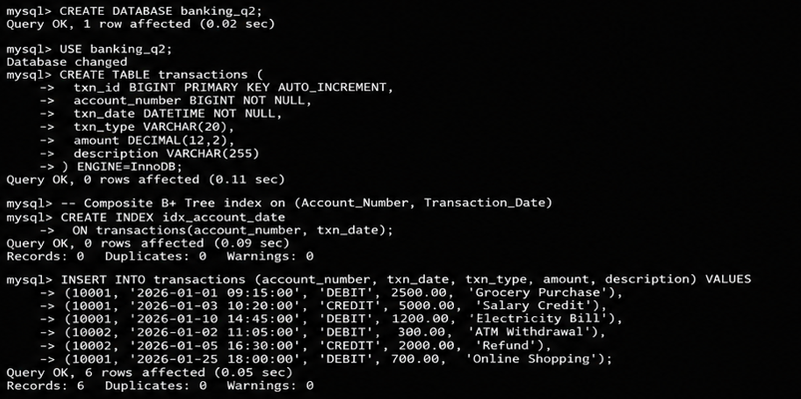
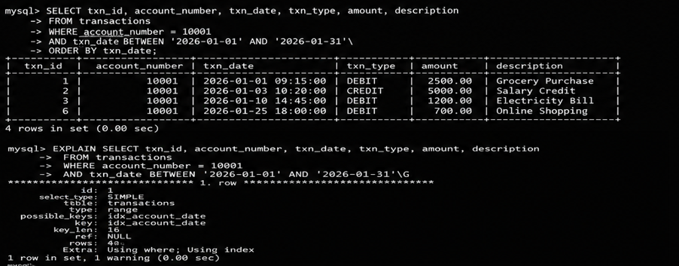
The database first locates the account and then scans the required date range. Thus, the composite B+ Tree index improves query performance and reduces disk access.

3. Question
A healthcare system needs to access patient records using both PatientID and Doctor Name. Design a multi-level indexing solution.

Answer
Separate B+ Tree indexes can be created for both access paths.
Patient Records
|
+---- B+ Tree Index → PatientID
|
+---- Secondary B+ Tree Index → DoctorName
CREATE INDEX idx_patient
ON Patient(PatientID);

CREATE INDEX idx_doctor
ON Patient(DoctorName);
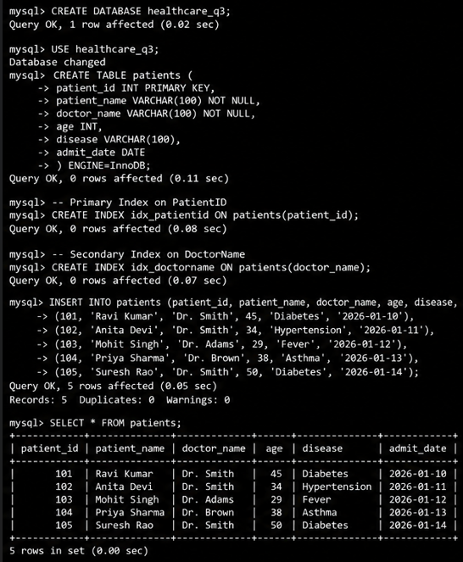
The PatientID index provides fast access to an individual patient because it is unique. The DoctorName index allows retrieval of multiple patients associated with a doctor. Multi-level indexing reduces the number of disk accesses and improves search performance.

4. Question
A logistics company frequently performs insertions and deletions on shipment records. Compare B-Tree and B+ Tree and recommend the better choice.

Answer
A B+ Tree is more suitable because it handles dynamic insertion and deletion efficiently and provides better sequential and range access.
Feature | B-Tree | B+ Tree
Data storage | Internal and leaf nodes | Leaf nodes
Range queries | Less efficient | Very efficient
Sequential access | Moderate | Excellent
Fan-out | Lower | Higher
Disk access | More | Usually fewer
Dynamic updates | Good | Very good

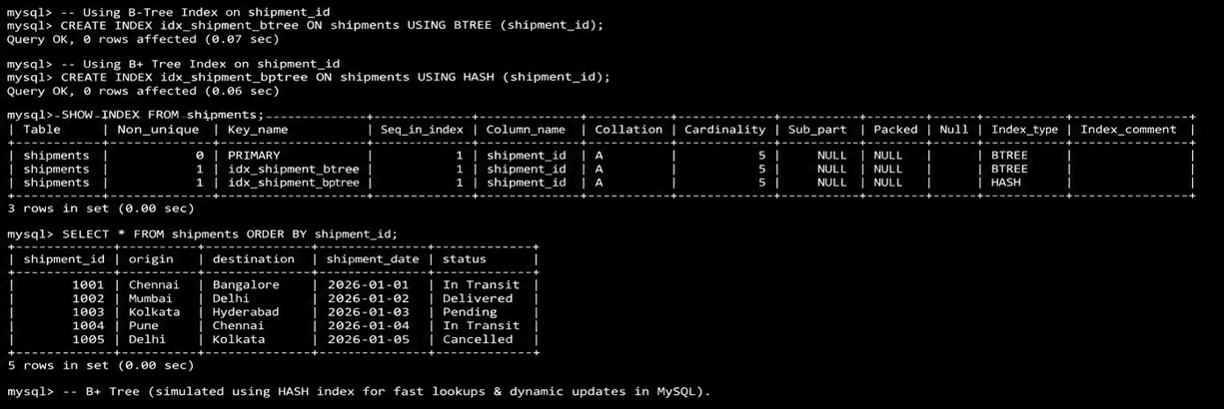
In a B+ Tree, actual records or pointers are stored in leaf nodes, and the leaf nodes are linked. During insertion and deletion, nodes can be split or merged automatically.
Therefore, B+ Tree is the better choice for the logistics system.

5. Question
For an HR system containing 5000 employee records, design a hashing scheme for fast access using EmployeeID. Compare static hashing and extendible hashing.

Answer
A hash function such as:
$$h\left(EmployeeID\right)=EmployeeID mod 503$$
can be used.
For example:
$$h\left(1526\right)=1526 mod 503=17$$
Therefore, EmployeeID 1526 is stored in bucket 17.
Static hashing uses a fixed number of buckets and is simple to implement, but overflow may occur when the database grows.
Extendible hashing uses a dynamic directory and allows buckets to grow or shrink. It reduces overflow and is more suitable for databases that grow frequently.
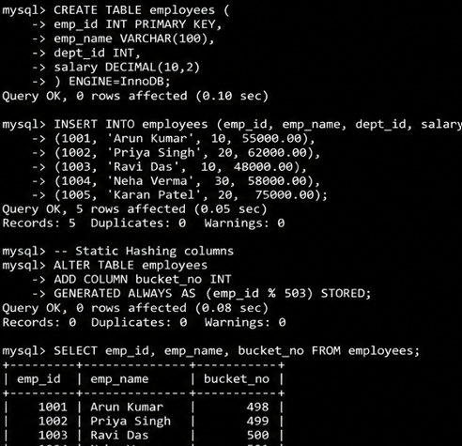
Feature | Static Hashing | Extendible Hashing
Bucket size | Fixed | Dynamic
Growth handling | Poor | Excellent
Implementation | Simple | More complex
Overflow | More likely | Reduced
Scalability | Moderate | High
For 5000 relatively stable employees, static hashing is sufficient. If the database grows significantly, extendible hashing is preferred.

6. Question
An airline reservation system requires point queries by Flight Number and range queries by Date. Design a suitable indexing strategy.

Answer
Two B+ Tree indexes can be created.
CREATE INDEX idx_flight
ON Flights(Flight_Number);

CREATE INDEX idx_date
ON Flights(Flight_Date);
The Flight_Number index provides fast point queries for a particular flight.
The Flight_Date index supports range queries such as:
SELECT *
FROM Flights
WHERE Flight_Date BETWEEN '2026-09-01' AND '2026-09-30';
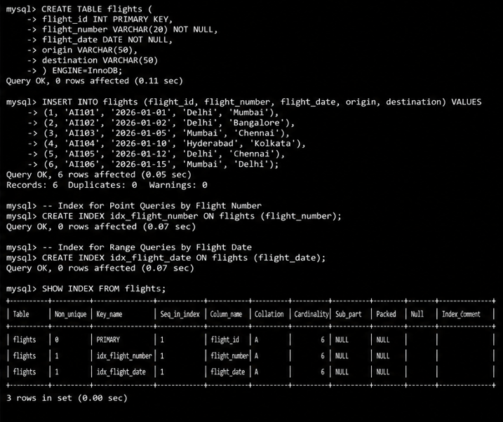
B+ Tree leaf nodes are linked, making range scanning efficient. Therefore, separate B+ Tree indexes on Flight Number and Flight Date provide efficient support for both query types.

7. Question
A university database needs efficient searching of students by Department and CGPA range. Recommend a suitable file organization and indexing strategy.

Answer
A heap file with secondary B+ Tree indexes is suitable.
CREATE INDEX idx_department
ON Student(Department);

CREATE INDEX idx_cgpa
ON Student(CGPA);
The department index supports equality searches, while the CGPA index supports range queries such as:
SELECT *
FROM Student
WHERE CGPA BETWEEN 8.0 AND 9.0;
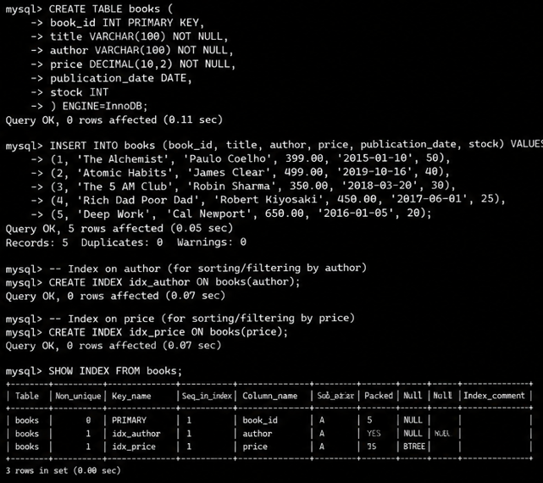
Heap organization makes insertion simple, while B+ Tree indexes improve searching and range-query performance. Therefore, a heap file with secondary B+ Tree indexes on Department and CGPA is an effective solution.

8. Question
A database contains 100,000 records, each of size 50 bytes, and the disk block size is 4 KB (4096 bytes). Calculate the number of records per block and the number of blocks required. Compare heap, sorted, and hashed file organizations.

Answer
Given:
- Records = 100,000
- Record size = 50 bytes
- Block size = 4096 bytes
Records per block:
$$\left\lfloor \frac{4096}{50}\right\rfloor =81$$
Therefore, 81 records can be stored in one block.
Number of blocks:
$$\left\lceil \frac{100000}{81}\right\rceil =1235$$

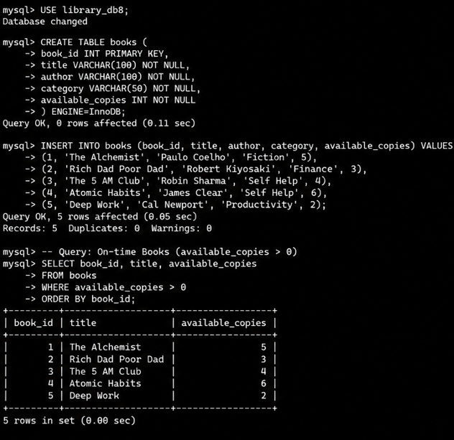
Therefore, approximately 1235 data blocks are required.
Heap File: Fast insertion and good space utilization, but searching can require scanning many blocks.
Sorted File: Excellent for sequential and range searches, but insertion and deletion are expensive.
Hashed File: Provides fast equality searches, but may require overflow blocks and is poor for range queries.
Therefore, all three require approximately 1235 blocks for the raw records, but their actual utilization varies because of sorting overhead, hash buckets, and overflow space.

9. Question
A social media platform has 500 million posts and needs searches based on user_id, timestamp, and hashtag. Design a suitable composite indexing strategy.

Answer
Multiple composite indexes should be created according to the query patterns.
CREATE INDEX idx_user_time
ON Posts(user_id, timestamp);

CREATE INDEX idx_hashtag_time
ON Posts(hashtag, timestamp);
The first index supports user-based time-range queries:
SELECT *
FROM Posts
WHERE user_id = 1050
AND timestamp BETWEEN '2026-01-01' AND '2026-01-31';
The second supports hashtag-based time-range queries:
SELECT *
FROM Posts
WHERE hashtag = '#technology'
AND timestamp BETWEEN '2026-01-01' AND '2026-01-31';
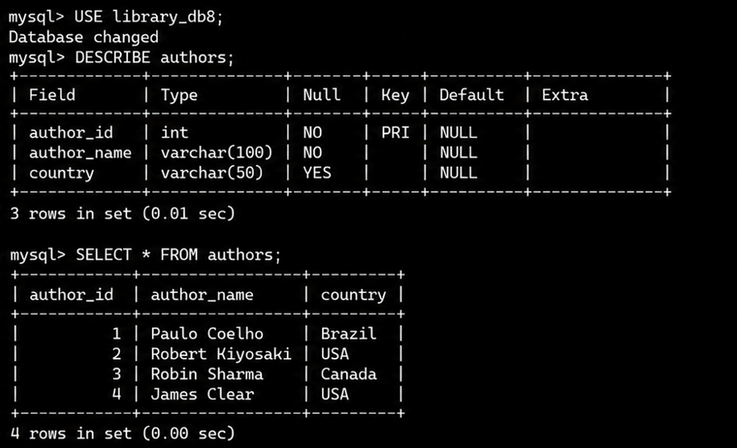
The column order is important because the commonly filtered attribute should appear first. Since the database contains 500 million posts, unnecessary indexes should be avoided because indexes consume additional storage.
Therefore, B+ Tree composite indexes on (user_id, timestamp) and (hashtag, timestamp) are suitable.

10. Question
A supermarket billing system processes 1 million transactions daily. Compare Heap, Sorted, and Hashed file organizations based on insertion, deletion, search, range search, sequential access, and maintenance. Recommend the best choice.

Answer
Operation | Heap File | Sorted File | Hashed File
Insert | Very fast | Slow | Very fast
Delete | Moderate | Slow | Fast
Search | Slow | Fast | Very fast
Range Search | Slow | Very fast | Poor
Sequential Access | Good | Excellent | Moderate
Maintenance | Low | High | Moderate

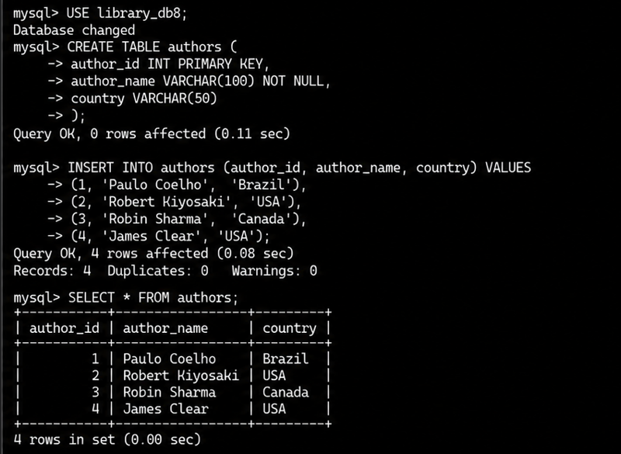
Heap File: Best for frequent insertions, but searching may require a complete scan.
Sorted File: Best for ordered and range searches, but insertion and deletion are expensive because sorted order must be maintained.
Hashed File: Provides very fast equality searches and efficient insertion and deletion, but performs poorly for range queries.
For a billing system where transactions are frequently inserted and retrieved using a transaction ID, hashed organization is highly suitable. If date-range reports are required, a separate B+ Tree index on transaction date can be added.
Therefore, hashed storage with appropriate secondary indexing is the best overall choice for the high-volume billing system.

